https://github.com/hzbu820/EC521-Final-Project
Victor: vsmercola
Hieu: Hieu-Nguyen1031

Project: Slop-Squatting
- Proposal: Browser Extension for Ransomware Slop-Squatting Attack
- Inspiration
  - Typo-squatting with AI
  - “Vibe coding” commonly used in industry & startups
- Action items
  - Poring through LLM prompt outputs to find package recommendations that don’t exist
  - Changing an LLM chatbot app’s UI to showcase a library’s “stats” on hover
  - Running virus scans on AI-recommended packages?
  - “Heads up, this code snippet relies on these packages” before copying code
  - Providing a list of best-practice packages per language? → Future work
- Demo
  - Browser extension that incorporates a sandbox that checks for malicious code
- Success Criteria
  - Published browser extension to Firefox / Chrome / whatever
  - 95% detection rate

Notes:
- Goal:
  - Build a browser extension
    - Adaptable to multiple coding languages
    - More on the browser extension:
      - Webextension API
      - Manifest
  - 2 Programs:
    - Desktop version which connects to a browser extension
    - Python backend
      - Security tools like bandit
      - XGBoost
- Recommendation:
  - Sandboxing library
    - Don’t run the code directly, that causes the Halting Problem
  - Run fully-isolated tests
    - Confirm that a package has tests to run, and then run them in a sandbox
      - Python: venv
  - How are we going to run Python libraries in a web-based sandbox?
- Don’t ask the LLM if it hallucinated a package
- Hamming distance
- Figure out the probability tree of the LLM’s response token-by-token
  - “I'd be particularly curious to learn whether you can predict what slop the LLM gives you to launch attacks that are more likely to be successful (compared to random package registrations).”

Action Item:
- Create the “oracle” (classifier) that tells the difference between AI-hallucinated packages and real packages
  - Ask LLM: “what [programming language] packages do you recommend for [use case]?” & record outputs
    - Run LLMs on local GPUs
    - Run LLMs on SCC
    - Automate proprietary LLMs with TerrierGPT https://terriergpt.bu.edu
  - Check validity of programming language packages w/ 3rd-party tools
    - GitHub stars
    - Snyk API stats
    - Total downloads
- Research typosquatting mitigation techniques and how to incorporate them into our “oracle” (classifier)
  - Hamming distance
  - Predict LLM’s response based on token
- Presentation:
  - Demonstration of our code doing what it said it does
  - VIDEO
    - 95% accuracy in predicting malicious packages
- Look for APIs (part of researching)
- Create chrome, firefox extension that we can inject into chatGPT
- Build a metadata fetcher
- “Oracle”

High lexical similarity to a known popular package (small edit distance).
Short, pronounceable names (human-friendly).
Name follows common language/package naming conventions.
LLM recurrence (appears across multiple model instances/prompts).
Prompt-topic alignment (name fits the requested API semantic).
No immediate registry presence (so an adversary can register it).

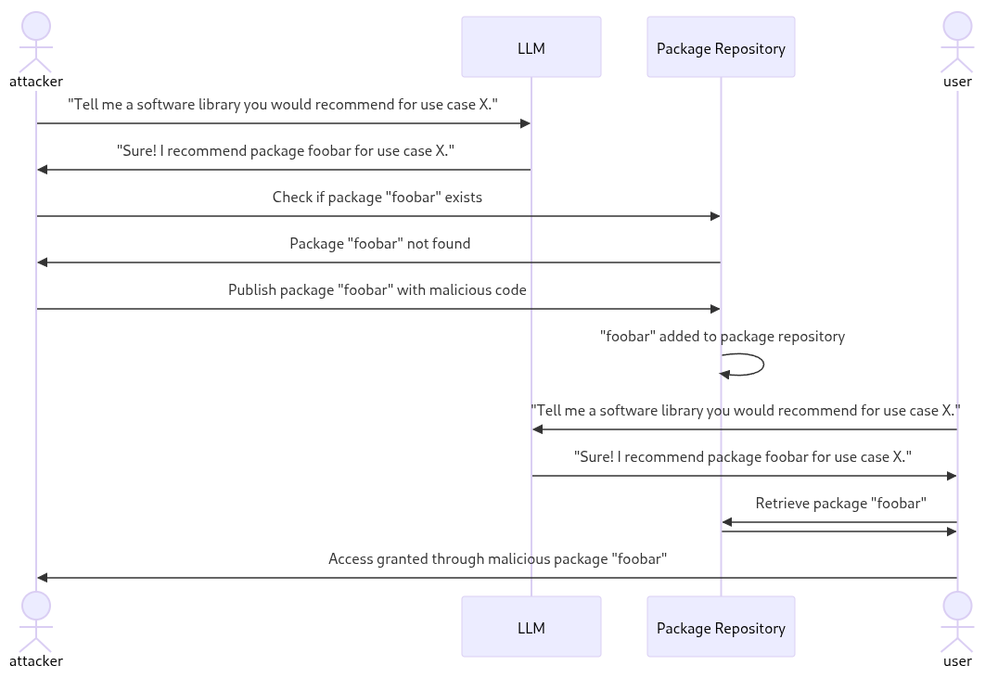

three main components:
- Browser Extension (Frontend)
Written in TypeScript, using the WebExtension API (Manifest V3).
Injects into Chat UIs, parses code blocks, and extracts package names (import, require, etc.).
Displays inline indicators (green/yellow/red) with hover-over metadata and warnings.
- Backend Service
Built with Python (FastAPI).
Functions:
Metadata fetcher (PyPI, npm registries, GitHub API, Snyk API).
Static heuristics engine (age, popularity, suspicious scripts).
Machine learning classifier (XGBoost or logistic regression).
Sandbox orchestrator for isolated dynamic tests.
Data storage: PostgreSQL (metadata/history), Redis (job queue/cache).
- Sandbox Environment
Isolated container/VM runner (Docker with gVisor/Firecracker).
Executes limited install/build steps under strict resource and time caps.
Collects signals: network calls, file system writes, obfuscation, suspicious post-install scripts.
Ensures zero risk to host system.

4.1 Data Collection

Ground truth packages: Collect 500+ real packages from PyPI and npm, spanning popular and obscure libraries.

Malicious examples: Include known incidents (e.g., event-stream on npm, malicious PyPI uploads).

Hallucinated names: Prompt LLMs for common coding tasks, record package suggestions, and identify non-existent ones.

4.2 Analysis Pipeline

Metadata Checks:

Existence in registry

Download counts, stars, dependents

Age of package and release cadence

Presence of GitHub repo

Heuristic Rules:

New package (<7 days old, no dependents) → suspicious

Similar name to popular package → suspicious

Post-install scripts, obfuscation, or console scripts → high risk

Machine Learning Classifier:

Features from metadata + heuristics

Model trained on labeled dataset (safe vs. malicious/hallucinated)

Expected output: risk score (0–1)

Sandbox Execution (optional, higher latency):

Run install in venv/container

Log system/network activity

Detect malicious behavior (file writes outside package dir, outbound requests).

4.3 Evaluation

Construct a balanced test set (~100 packages, safe + malicious + hallucinated).

Metrics: precision, recall, F1 score, confusion matrix.

Success: ≥95% recall on malicious packages with <5% false positives.

MILESTONE:

Finalize threat model and dataset collection
Build extension skeleton (manifest, content script, badge overlay)
Implement FastAPI backend + metadata fetcher

Add static heuristics and basic classifier
Integrate backend with extension
Build initial UI for metadata display

Implement sandbox runner for dynamic analysis
Expand dataset with hallucinated names + malicious packages
Train and evaluate ML model

Perform adversarial testing (obfuscation, similar names)
Refine classifier thresholds
Polish UI, add caching, prepare demo video

Working extension in dev mode
Backend with documented API
Dataset and evaluation report
Final presentation/demo/video recording

10/5/2025

Member | Primary Role | Tasks | Key Skills
Oscar (Frontend Lead) | Browser Extension | Build Chrome/Firefox extension (Manifest V3, TypeScript), inject into ChatGPT UI, highlight packages, show warnings | WebExtension API, JS/TS
Victor (Backend Lead) | FastAPI Server | Build API endpoints for metadata fetcher (PyPI, npm, GitHub), integrate heuristics and ML model | Python (FastAPI), REST APIs
Kevin  (ML & Data Lead) | Oracle Classifier | Collect dataset (real/malicious/hallucinated), extract features, train XGBoost/logistic regression, evaluate | Python (pandas, scikit-learn, XGBoost)
Hieu (Sandbox & Research) | Sandbox + Security | Build Docker-based isolated runner, integrate gVisor/Firecracker, collect behavioral signals, test malicious packages | Linux, Docker, system sandboxing

Frontend: JAVA SCRIPTor Type

EC521-Final-Project/
│
├── frontend-extension/ # (Person A)
│ ├── src/
│ │ ├── content/
│ │ │ └── contentScript.ts # Injects into ChatGPT UI
│ │ ├── popup/
│ │ │ ├── popup.html
│ │ │ └── popup.tsx # Optional UI popup
│ │ ├── background.ts # Handles backend communication
│ │ └── utils/
│ │ └── parser.ts # Extracts package names from code
│ ├── assets/
│ │ ├── icon16.png
│ │ ├── icon48.png
│ │ └── icon128.png
│ ├── manifest.json # Manifest V3 config
│ ├── package.json
│ ├── tsconfig.json
│ ├── README.md
│ └── webpack.config.js # Build setup for TS → JS
│
├── backend-api/ # (Person B)
│ ├── app/
│ │ ├── main.py # FastAPI entry point
│ │ ├── routers/
│ │ │ ├── check.py # /check_packages endpoint
│ │ │ └── health.py # /health endpoint
│ │ ├── core/
│ │ │ ├── config.py # settings & env variables
│ │ │ ├── database.py # Postgres connection
│ │ │ └── cache.py # Redis cache setup
│ │ ├── services/
│ │ │ ├── metadata_fetcher.py # PyPI, npm, GitHub, Snyk APIs
│ │ │ ├── heuristics.py # Static rules
│ │ │ ├── classifier.py # ML model loading/scoring
│ │ │ └── sandbox_runner.py # Docker isolated runner
│ │ ├── models/
│ │ │ └── package_model.py # Pydantic models
│ │ └── utils/
│ │ └── logging_config.py
│ ├── requirements.txt
│ ├── Dockerfile
│ ├── README.md
│ └── run.sh
│
├── data-ml/ # (Person C)
│ ├── datasets/
│ │ ├── pypi_real.csv
│ │ ├── npm_real.csv
│ │ ├── malicious.csv
│ │ └── hallucinated.csv
│ ├── notebooks/
│ │ ├── data_cleaning.ipynb
│ │ ├── feature_extraction.ipynb
│ │ ├── train_classifier.ipynb
│ │ └── evaluation.ipynb
│ ├── models/
│ │ ├── xgboost_model.pkl
│ │ └── logistic_model.pkl
│ ├── src/
│ │ ├── features.py # Extract features from metadata
│ │ ├── train.py # Model training script
│ │ └── evaluate.py # Evaluate accuracy/F1
│ ├── requirements.txt
│ └── README.md
│
├── sandbox-env/ # (Person D)
│ ├── Dockerfile
│ ├── runner/
│ │ ├── sandbox.py # Executes package install in isolation
│ │ ├── monitor.py # Logs network/filesystem behavior
│ │ └── rules.yaml # Detection heuristics
│ ├── tests/
│ │ ├── benign_package/
│ │ └── malicious_package/
│ ├── README.md
│ └── run_sandbox.sh
│
├── docs/
│ ├── architecture-diagram.png
│ ├── presentation-slides.pptx
│ ├── evaluation-report.md
│ └── final_video_link.txt
│
├── .gitignore
├── README.md # Main overview + how to run
└── LICENSE

Links:
https://developer.mozilla.org/en-US/docs/Mozilla/Add-ons/WebExtensions/What_are_WebExtensions
https://github.com/hzbu820/EC521-Final-Project

